Topic Outline for Historical Context
Use this template as a guideline for your outline:

General Information
- Note: a “Sentence Outline” is also acceptable.
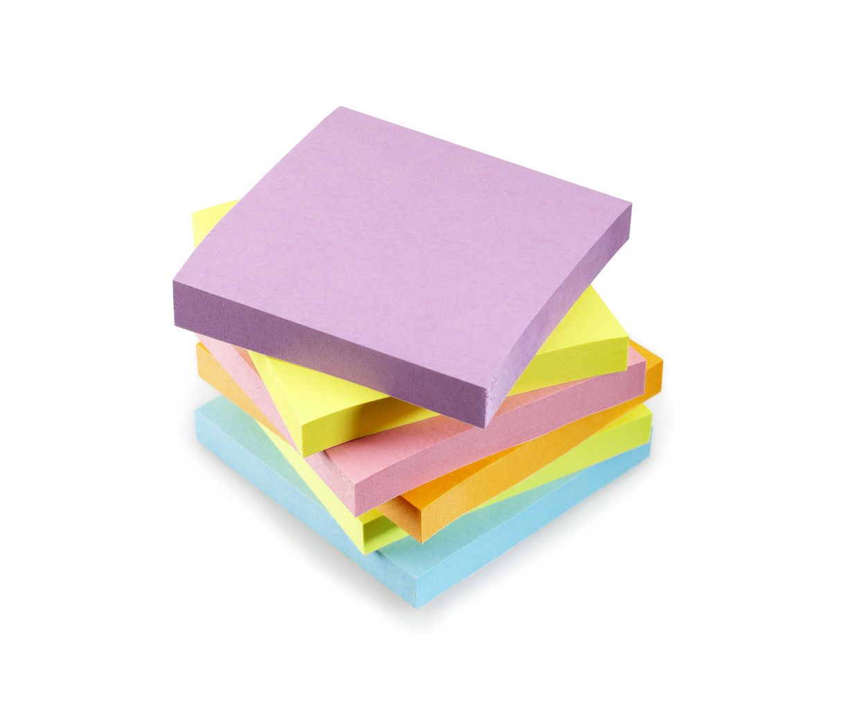

I. (The Context) – Life in the U.S. from _____ to _____ (ten year period – 5 years before/after)
Main headings (Roman Numerals) might have an article followed by a prepositional phrase or include a question.
- Introduction

- Politics

1. Important leaders

2. Issues
Use parallel structure within each of the components of the outline.

3. Foreign relations

C. Science

1. New technology

2. Medicine
The “A,” “B,” “C” Subheadings should “match,” perhaps as just a noun or as a noun with modifier(s).

(3. Add own ideas)

D. Entertainment

1. Drama/movies
Sub-points (1, 2, 3…) can be single words or phrases, but all should be similarly written.
2. Literature

3. Sports

4. Music
Historical Event Outline is on reverse.

5. Home entertainment

(6. Add own ideas)

E. One of the following five sub-topics:
Economy, Education, Religion, Fashion, Daily Life

F. Another of the following five sub-topics:
Economy, Education, Religion, Fashion, Daily Life

G. Conclusion

NAME:
Topic Outline for Historical Event
Use this template as a guideline for your outline:

II. (The Historical Event) – Whatever your event is…

A. Description of the event that you researched

- Include dates and details (adapt outline as needed to match paragraphs).

B. Importance of the event you researched

- Explain why this event is important in American history (adapt outline).

More Guidelines for Outline Pages:

At the top of your outline page, center the word “Outline”.

Then add the rest of the outline information. You can use the Auto-Format feature in your word processing program (MS Word, Open Office, Google Doc, etc.) or format it yourself, with each indent ½” (one tab) beyond the last. You may need to use the “undo” feature to tweak the outline so that it is consistent throughout. Variations between papers will be accepted, but each individual outline should be consistent and visually appealing.

Your outline should match your paper, clearly reflecting the different paragraphs. Whenever possible, please come up with alternate ways of describing the sections (not just “context”, “event”, and “importance,” etc. as your section headings).

The outline contents itself can be one of two forms: a sentence outline or a topic outline. A sentence outline has a complete sentence for each point on the outline, while a topic outline just uses a word or phrase for each point. Pick one method and stick with it for the whole outline. Either is acceptable. Begin each point with a capital letter, but don’t end with punctuation unless you have written a complete sentence.

Remember to use parallel structure in your outline. This means that each heading level is written similarly. For example, if your first Roman Numeral heading is a question, your other Roman Numeral headings should also be questions. If your first sub-heading is made of an adjective and a noun, your other sub-headings in that section should contain an adjective and a noun, as well.
The sample outlines are both topic outlines (you may use the digital version and tweak it with your content). Notice the way each level is labeled and note that there is never just one sub-point. If you are going to have an “A”, you should have at least a “B”, too; if you put a “1”, you should at least have a “2” to go with it. That will ensure that your paragraphs have good substance to them.

You can also use this online outline maker: http://www.crlsresearchguide.org/NewOutlineMaker/NewOutlineMakerInput.aspx

